Gender Bias   
in Job Descriptions

Liron Cohen 207481268

Yuval Mor 209011543

Ofer Tlusty 311396303

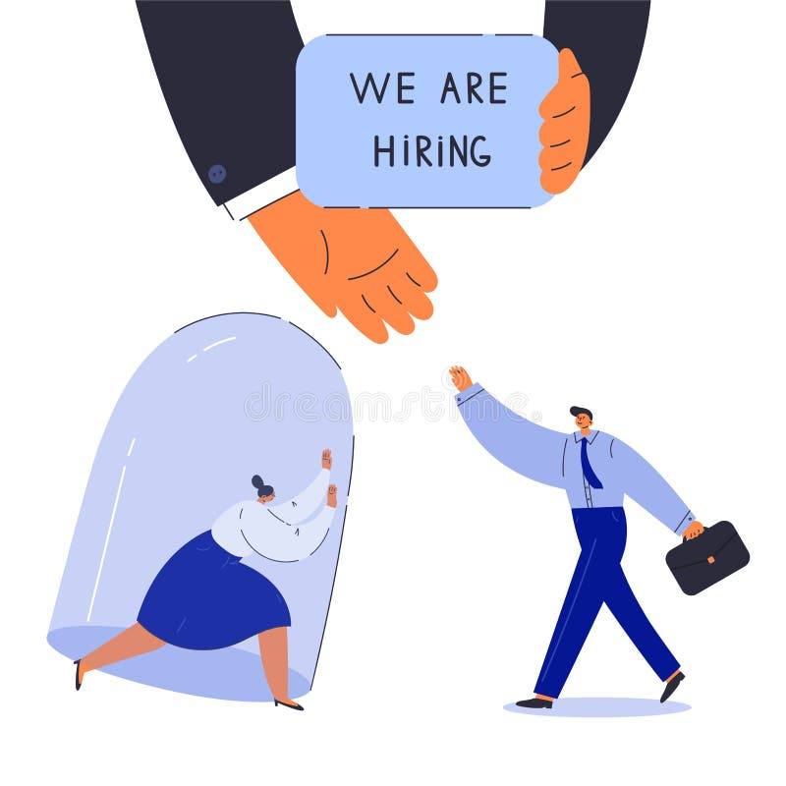

Table of Contents

Theoretical background 3

Research problem 5

Research target 5

Research questions 5

Research method 6

Findings 7

# Theoretical background

Cultural and social constructions have been studied in relation to the labor market, with particular focus on the influence of gender. Gender, as a term, encompasses the cultural system of structural arrangements within the context of biological sex. Its meaning is shaped not only by the opposite gender but also by various societies, cultures, and fields. These gender-based constructions prevalent in society have been replicated in the labor market, resulting in inequalities. These inequalities manifest in wages, benefits, demands, expectations, and even in the perception of specific roles when performed by different genders.

In today's labor market, although there is a significant number of women, many organizations remain gender-dominated, with certain characteristics and qualities attributed primarily to one gender. Such cultural systems play a significant role in determining the roles expected to be fulfilled by men and women. One area where these gender inequalities are evident is the underrepresentation of women in science and engineering professions ([Women in Hi-tech industry 2022](https://innovationisrael.org.il/sites/default/files/%D7%93%D7%95%D7%97%20%D7%A0%D7%A9%D7%99%D7%9D%20%D7%91%D7%94%D7%99%D7%99%D7%98%D7%A7%202022.pdf), Innovation Israel).

Gender bias is a pervasive issue that permeates various aspects of society, including the workplace. It is well known that women often experience discrimination in hiring, promotions, pay, and job assignments. Stereotypes and preconceived notions about gender roles influence how individuals are perceived and evaluated, leading to unequal treatment and limited opportunities. These biases can manifest subtly, including in the language used within job descriptions.

The software engineering industry, known for its historical male-dominated nature ([Technology Trends, Shubhomita Bose](https://smallbiztrends.com/2018/03/women-in-technology-statistics.html)), demonstrates significant gender bias. This bias is characterized by imbalances in the representation of men and women in the field, which have persisted over time.

Job descriptions play a crucial role in shaping potential applicants' perceptions of a position and an organization. They serve as the initial point of contact between candidates and the job market. However, research suggests that gender bias can be embedded in the language and content of job descriptions, inadvertently deterring qualified women from applying.

This literature review aims to examine the gender-based differences in job descriptions within the software engineering industry, shedding light on the impact of job characteristics on women's job application decisions. Understanding these differences is crucial for promoting gender equality and fostering diversity within the field. By identifying and addressing discriminatory language and practices in job descriptions, we can assist recruitment teams in creating more inclusive and welcoming environments that attract and retain talented women.

We drew significant inspiration from Moran Weber's post titled "[How to Attract More Women (and not the way you think)](https://medium.com/hackernoon/how-to-attract-more-women-and-not-the-way-you-think-372203f5a7d7)", which offers practical suggestions for encouraging women to apply for jobs by addressing language characteristics. The recommendations include avoiding gender-related superlatives, refraining from describing a masculine environment, fostering a workplace that supports work-life balance for parents and more. These ideas align with the findings of "[Evidence That Gendered Wording in Job Advertisements Exists and Sustains Gender Inequality](https://www.fortefoundation.org/site/DocServer/gendered_wording_JPSP.pdf?docID=16121)" by Danielle Gaucher, Justin Friesen, and Aaron C. Kay.

In this workshop, our objective was to develop a tool that assists recruitment teams in avoiding practices that discourage women from applying for jobs, incorporating insights from the papers we have studied.

Upon completing our research and transitioning to the writing phase of this paper, we discovered that several tools have already been developed to address similar topics and assist recruitment teams. Notable examples include [Ongig](https://www.ongig.com/gender-bias-in-job-descriptions#/) and [Textio](https://textio.com/), both of which aim to provide support in creating more inclusive and effective job descriptions. These tools align with our goal of aiding recruitment teams in developing gender-inclusive job descriptions that attract diverse candidates.

# Research problem

The research problem addressed in this paper is the presence of gender bias in job descriptions within the software engineering industry. Despite the significant number of women in the labor market, women are underrepresented in science and engineering professions. This underrepresentation can be attributed to inequalities and biases embedded in job descriptions, which deter qualified women from applying for positions. Therefore, there is a need to understand the gender-based differences in job descriptions and their impact on women's job application decisions in order to promote gender equality and diversity within the field.

# Research target

1. To identify and analyze the gender-based differences in job descriptions within the software engineering industry.
2. To understand the role of language and content in job descriptions in perpetuating gender bias and limiting opportunities for women in software engineering.
3. To explore practical strategies and recommendations for creating more inclusive and gender-neutral job descriptions that attract diverse candidates.

# Research questions

1. What are the gender-based differences in job descriptions within the software engineering industry?
2. How does language and content in job descriptions contribute to gender bias and unequal treatment of women in software engineering?
3. What are the practical strategies and recommendations for creating more inclusive and gender-neutral job descriptions that attract diverse candidates?
4. What are the potential challenges and limitations in implementing gender-inclusive language in job descriptions, and how can these be addressed?
5. What are the implications of gender bias in job descriptions for promoting gender equality and fostering diversity within the software engineering industry?

# Research method

## Population

The population for this research includes recruiters and hiring managers within the software engineering industry. These recruiters are responsible for creating and writing job descriptions and selecting candidates for interviews. They play a crucial role in shaping the language and content of job descriptions, and their awareness and understanding of gender bias can have a significant impact on promoting gender equality and diversity within the field. By examining the language and content of job descriptions created by these individuals, this research aims to identify and analyze gender-based differences and their impact on women’s job application decisions. Furthermore, by exploring practical strategies and recommendations for creating more inclusive and gender-neutral job descriptions, this research can provide valuable insights for recruiters and hiring managers to attract diverse candidates and promote gender equality within the software engineering industry.

## Research process - yuval

1. בתהליך המחקר יש לתאר **גם**צעדים/שלבים שלא הצליחו ולהסביר מדוע, ההתלבטויות שהיו לכםן במהלך המחקר, ודרכי/עקרונות קבלת החלטות שהנחו אתכםן.

1. אין לנו דאטה מתוייג.

2. סקר לשם תיוג (לא מספיק)

3. תיוג עם מודל שפה

3.5. בניית פרומפט אידיאלי למודל שפה והקשיים בדרך.

4. אין לנו דאטה של תיאורי משרה מפלים.

5. ג'ינרוט עם מודל שפה - להראות את הקושי (מה צריך כדי שהוא יסכים לעשות עם זה ודוגמאות למקרים שהוא מגזים, הצריך הרבה fine turning )

6. מודל שפה לא מתייג טוב משרות שלמות, מעבר למשפטים.

7. אימון מודל על דאטה לא מאוזן

## Data collection tools - yuval

2. על איסוף הנתונים לכלול לפחות 2 כלים – אחד ידני (סקר, ראיונות.... ) ושני אוטומטי web scraping או מאגר נתונים גדול אחר ממאגרי מידע שונים.

## Data analysis method(s) - yuval

## Ethical Considerations

In conducting the workshop on gender bias in job descriptions, it is important to address specific ethical considerations that emerged during the research process. These considerations revolve around privacy concerns and the potential biases inherent in the methods used to analyse and generate gender-biased sentences. By recognizing these ethical issues, researchers can work towards mitigating any potential negative impacts and ensuring the integrity of the study. The following ethical considerations should be considered:

1. Privacy Protection: The workshop encountered a challenge in obtaining company-specific data regarding the number of male and female applicants for specific job descriptions. This lack of access to data compromised the research process and necessitated alternative approaches, such as using GPT as a judge to assess gender bias. However, it is essential to respect the privacy of organizations and individuals involved.
2. Biases in Labelling and Sentence Generation: The workshop involved manual labelling of sentences to identify gender bias, as well as using GPT and BARD to generate gender-biased sentences. It is important to acknowledge that these methods can introduce biases themselves. We must be transparent about the limitations and potential biases in the labelling process, addressing any challenges and uncertainties associated with subjective judgment. Additionally, using GPT and BARD to generate biased sentences raises ethical concerns.
3. Ethical Use of Findings: The findings and recommendations derived from the workshop should be used responsibly and ethically. It is important to avoid misusing the results to perpetuate bias or discriminate against any gender. Instead, the findings should serve as a basis for raising awareness, fostering dialogue, and promoting positive change within the software engineering industry. Responsible application of the research can contribute to creating more inclusive job descriptions and recruitment practices.

By actively considering and addressing these ethical considerations, researchers can ensure that the workshop promotes fair and unbiased practices within the software engineering industry. Transparency, privacy protection, and responsible use of findings should guide the research process to facilitate a positive impact on gender equality and diversity.

## Research limitations - liron

# Findings -

Discussion

Research contribution (theoretical and practical)

Conclusion

Follow up research

Personal assignment – Yuval Mor

**עבודה אישית:**העבודה האישית פתוחה. ניתן לשתף בתהליך הלמידה (בהקשר לתחום הדעת, מחקר, עבודת צוות, כישורים שלכםן), מחשבות מקצועיות שונות וכל דבר שיראה לכםן רלוונטי כסיכום התהליך

עד 2 עמודים כל אחד.

הנה מספר נושאים שהועלו בכתה. ניתן כמובן להתייחס לנושאים אחרים. תודה לעופר על הסיכום.

**Personal assignments guidelines:**

1)      Teamwork:

* a.       What was your role in the team?
* b.       How was it to work as a team?
* c.       How was the communication between the team members?

2)      Researching people analytics:

* a.       What was your experience learning about the subject of your research?
* b.       Describe your experience in conducting research?

3)      How was the experience working in agile technique?

Those are only suggestions brought up in class, there may be a lot more to cover :)

Personal assignment – Liron Cohen

As a female student and software engineer, I experience the gender gaps that exist between men and women in the high-tech field on a daily basis - starting with education at a young age, choosing science and technology majors in high school, recruitment for technological positions in the army, acceptance for scientific academic degrees, acceptance for workplaces and technological positions, and more.

The path of women to the high-tech industry begins at an early stage in their lives. Choices of high school majors greatly influence the continuation of their professional path and their chances of entering the field in the future. In order for women to become entrepreneurs or hold senior positions in high-tech companies they must acquire education and training relevant in order to progress within the industry.

As of 2022, at the beginning of the way, in the Bagrut exams at the level of 5 study units in mathematics, there is almost gender equality. But, the gender gap is starting to open in the army service, in the R&D and cyber positions in the IDF, which pave the way for those who serve in them to the arena of Israeli innovation, where women are only 23% from those serving in these positions.

In the scientific subjects in the academy it is better, but even though the number of female students increased by 64% within a decade, their relative share increased by a few percentages and we are less than a third of the students in these subjects in the academy.

Further down the road with senior levels, the share of women in the industry goes down. As of 2022, only 28% of employees in technological positions in Israeli high-tech are women.

On the personal side, I started to be active in the pursuit of equality between men and women in the technological professions during my military service. I decided that I wanted to take an active part and help girls and young women reach significant technological positions in their military service, in their academic career and in their work in high-tech after that. Therefore, I volunteered for a long time as an instructor and track coordinator in the organization she codes;.

she codes is a technological community of women software developers, established with the aim of reaching 50% software developers in Israel. The members of the community are women who wish to learn software development, developers who want to meet other developers, and high school-aged girls who study programming. The core values of the organization are belief in yourself, perseverance and community, values in which I also believe.

During my volunteering at the organization, I met a lot of girls and women with exciting and special stories, and I was moved when each community member succeeded in achieving her goal and was accepted for a technological position in one of the Israeli high-tech companies, as another step towards the long-awaited equality.

As part of the process, I was exposed to quite a few women who were afraid to submit their resumes for jobs, claiming that they do not meet all the criteria, they are not good enough, there are better candidates than them, and more. I wanted to act to eradicate this phenomenon, and during a conversation with Adva Regev, a recruiter in the group where I work at Microsoft, we decided to investigate the issue and contribute to the recruitment of women in the company in general.

After this conversation, we had the opportunity to participate in this workshop and put the idea into action. I was happy to cooperate with Adva and the other members of her team, and to get the human resources angle on this problem. Together with the members of our team, we held several joint meetings and thought about how to create tools that would help women in human resources create job descriptions accessible to women, which would not discourage women from applying but would encourage them to apply.

Of course, the more women submit resumes for the job, both the women will benefit and the companies themselves will benefit from diverse, specialized and more inclusive employees.

In conclusion, my connection to gender equality in the Israeli high-tech industry is both professional and personal. As a female student and software engineer, I experienced and continue to experience the advantages and challenges of being a woman in a field that is mostly made up of men. This workshop gave me an opportunity to learn about human resources and data analysis, to experience collaboration with different people and the research process in all its aspects.

I hope that this research will be one of many steps in the pursuit of gender equality in the Israeli high-tech and in general.

Personal assignment – Ofer Tlusty

In the framework of the workshop, I had the opportunity to experience a completely different form of learning than what is commonly practiced in the university, especially in engineering and exact science faculties. The task was undefined, and so was the topic of the work. The lecturer spoke to us about emotions, feelings, and research (something amorphous?) instead of evidence, techniques, and algorithms - I won't lie, the confusion was significant.

Throughout my life, I have made sure to dedicate some of my time to volunteering, mostly in the field of education and occasionally in other areas. However, I have never delved into the field of gender and the disparities between women and men. Liron raised the topic, and along with the opportunity to work with students in occupational studies, we had a good feeling that it was an important and interesting subject worth investing time and effort in.

*Embracing Modesty and Humility*

The process began with reading articles and posts (with emphasis on the amazing blog by Moran Webber!). I always knew there was a gap, but the small details about how deeply it was ingrained in us, in our language, in the most basic habits, were both shocking and fascinating. The more I delved into it and shared my findings with my close surroundings, I discovered two things: first, even the women in my environment were not always aware of these hidden aspects (especially the men), and secondly, they identified with the feelings even when I somewhat belittled them because as a man, I didn't imagine they would resonate with some of the criticisms – from my perspective, it was an important lesson in modesty and humility.

After learning about the topic, we wanted to connect with the students' task in the parallel course. We held a synchronization and expectation coordination meeting and found that there was a good connection. We contributed our ability to provide value to them with automated tools and data analysis, and they guided us on where our impact would be expressed in the field of human resources. Due to the different schedules between the courses, we had to adjust and "jump in the water".

We formulated a relatively quick task without deep characterization of the broader research context we were required to adhere to, and we completed the task to enable the parallel group to continue their work. Later on, we used the basic output transferred to the parallel group as a "review" means for potential features in the model we developed, but collaboration with the parallel group came to an end due to scheduling incompatibilities – I believe that if we had better alignment, we could have achieved more significant results and learned more from this unique collaboration.

*Being Agile and Adaptive*

Our next challenge was to obtain relevant data repositories for our task. My main effort was to try to obtain a tagged data repository from a private company or association that would reflect the distribution of women and men who submitted resumes for a job. I tried reaching out to recruiters at Apple (where I work), to companies of friends from the high-tech industry, and even to utilize a family member's connection who has been working for years in employment in the Arab sector in order to establish contact with the "Aluma" association (managers of a course that involves students in the employment world as part of their studies), but all my collaborative efforts fell due to the privacy policies of the companies.

*Perseverance and Creativity in the Face of Challenges*

The enlightening suggestion by Yuval to use language models like GPT and/or BARD as a tagging model for the job descriptions we found was no less than exciting. We knew there would be challenges in the process (we didn't realize how many), but thanks to perseverance, we managed to create a model that even produced good results in a short period.

From this moment, I felt like I returned to my comfort zone. We have a database, we found a suitable model that could deal with the received data, generate graphs and histograms, and analyze the results obtained. We went back to cleaning the data repository, improving the accuracy of the model, fine-tuning the graphs or the extracted results, and drawing conclusions from them.

This workshop allowed me to explore various aspects that I was not familiar with, from the research field of gender in the world of employment, through the research work itself, and even touching on the world of NLP and its practical application for solving real problems.

Thank you for the process, and good luck,

Ofer